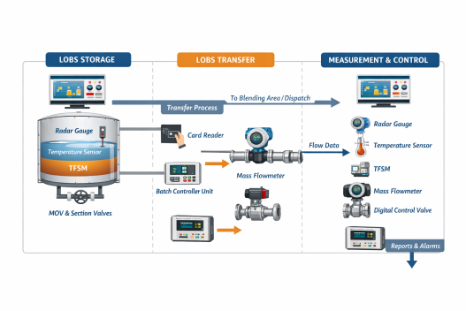
11 LOBS (Lube Oil Base Stock)
Lube Oil Base Stock (LOBS) forms the primary component in lubricant production. It is stored, transferred, and controlled using advanced automation systems to ensure quality, safety, and accuracy in blending and distribution.

11.1 Storage

LOBS is stored in large, specially designed storage tanks that ensure product quality, safety, and proper inventory management. These tanks are equipped with radar gauges for continuous and highly accurate level measurement without direct contact with the liquid. In addition, temperature sensors are installed to monitor the thermal condition of the oil, as temperature variations can affect viscosity and overall product quality. Maintaining stable storage conditions is essential to prevent degradation and ensure consistency in downstream processes.
The storage system is centrally managed by the Tank Farm Management System (TFSM), which provides a complete overview of tank inventory, status, and historical data. Along with TFSM, the SCADA (Supervisory Control and Data Acquisition) system plays a key role by offering real-time monitoring, alarm generation, and remote operation capabilities. Operators can easily track parameters such as tank levels, temperature, and valve status through SCADA interfaces, ensuring efficient and safe operations.
Flow control within the storage section is achieved using motor operated valves (MOVs) and section valves. MOVs allow automatic control of inflow and outflow of LOBS, while section valves are used to isolate specific tanks or pipeline segments during maintenance or emergency situations. Together, these components ensure safe handling, proper routing, and effective management of LOBS within the storage facility.

11.2 Transfer
The transfer of LOBS from storage tanks to blending units or dispatch points is carried out through a well-controlled and automated pipeline system. The process begins with operator authentication using a card reader, which ensures that only authorized personnel can initiate transfer operations. This adds a layer of security and accountability to the system, preventing unauthorized access and operational errors.
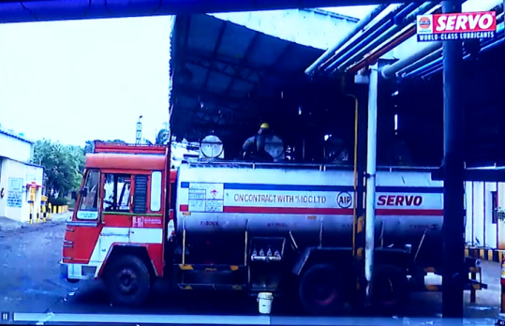
Once authorization is completed, the transfer process is executed by the Batch Controller Unit (BCU), which is programmed with predefined batch quantities. The BCU ensures that the exact required amount of LOBS is delivered for each operation. During transfer, the oil flows through pipelines where a mass flowmeter continuously measures the flow rate and total quantity with high precision. This ensures accurate tracking of material movement and supports efficient process control.
Flow regulation is handled by a digital control valve, which automatically adjusts based on feedback from the system to maintain the desired flow rate. Motor operated valves (MOVs) and section valves are used to control and direct the flow path, ensuring proper routing and isolation when needed. Throughout the transfer process, the SCADA system monitors all parameters in real time, provides alerts in case of deviations, and enables operators to control the system remotely, ensuring safe and efficient transfer operations.

11.3 Measurement & Control
The measurement and control section plays a crucial role in ensuring the accuracy, safety, and efficiency of LOBS handling operations. Various instruments such as mass flowmeters, radar gauges, and temperature sensors continuously collect data related to flow, level, and temperature. This real-time data is essential for maintaining process consistency and ensuring that operational parameters remain within specified limits.
All the collected data is transmitted to the SCADA system, which acts as the central platform for monitoring and control. SCADA provides real-time visualization, data logging, and alarm management, allowing operators to quickly identify and respond to any abnormalities. In parallel, the Tank Farm Management System (TFSM) integrates this data to provide detailed insights into inventory levels, tank utilization, and overall system performance, supporting effective decision-making.
The system operates on a closed-loop control mechanism, where the digital control valve adjusts the flow rate based on feedback from the mass flowmeter and control systems. The Batch Controller Unit (BCU) ensures that precise quantities are delivered during each operation. Safety is further enhanced through alarms, interlocks, and automatic shutdown features, which protect the system from overflows, temperature deviations, and other potential hazards. This integrated approach ensures reliable, accurate, and efficient operation of the LOBS system.

12 SAFETY
Heath, Safety & Environment: The three pillars to ensure safe communities and happy stakeholders
At IndianOil, we believe that it is possible to fuel the energy needs of the Nation while also protecting people and the environment. We are committed to conducting business in a manner that is compatible with the environmental and economic needs of the communities in which we operate, and that protects the safety and health of our employees, those involved with our operations, our customers and the public.
IndianOil accords topmost priority to conducting its business with a strong environment conscience, ensuring sustainable development, safe workplaces and enrichment of the quality of life of its employees, customers and community at large. All refineries are certified to ISO:14064 standards for sustainable development as well as for the Occupational Health & Safety Management System (OHSMS/OHSAS18001), besides having fully equipped occupational health centres. Compliance with safety systems, procedures and environment laws is monitored at the unit, division and corporate levels.
As India's leading oil & gas corporate, IndianOil remains steadfast in its commitment to excellence in Health, Safety and Environmental (H,S&E) performance. This publication showcases how IndianOil people are relentlessly pursuing multiple commitments - at the operations, social and environmental levels - to fully realize IndianOil’s potential as the prime mover of a resurgent India.
Safety Management at IndianOil
IndianOil is committed to safety and demonstrated leadership in the field of Health, Safety and Environmental. The Health, Safety and Environmental (H,S&E) policy of IndianOil demonstrates this commitment. IndianOil has a well-defined Health, Safety and Environmental (H,S&E) Policy that gives direction for various safety, occupational health and environment protection related activities. The safety & fire protection measures at IndianOil encompass a well-sensitised Management, focus on imparting regular training and a culture of safety throughout the Company.
Well-sensitised Management
Employee Participation:To boost safety consciousness, all the employees and others related to our operation are involved in the safety culture. Safety Committees play vital role in this regard. Representatives of the workmen and officers work together in the Location Safety Committees. Safety awareness is enhanced by observance of Safety Day every month and safety performance is encouraged through safety awards.
Safety is reviewed in the Local Management Committee Meetings chaired by Unit Head/Installation Head. Functional Directors on the Board of IndianOil review safety performance in the monthly Performance Review Meetings.
The Board of Directors are appraised on safety performance with regard to implementation of recommendations of External Safety Audit (ESA) on regular basis. Major incidents and corrective actions taken are also appraised to the Board.
Culture of Safety
Process hazards are reviewed at all phases of project life by multidisciplinary teams. Hazard and Operability (HAZOP) study and Risk Analysis are carried out to identifify, assess and control process hazards. Quantitative Risk Analysis (QRA) is carried out for new unit or facilities and actions are taken to mitigate or minimize the hazards.
For new projects, pre-commissioning checks and audits are carried out by multi-disciplinary teams and deviations, if any, are corrected before start up. Also pre-commissioning audit is carried out by the Oil Industry Safety Directorate (OISD) for new units/ installations.
Mechanical integrity of equipment/ system is ensured through condition monitoring, periodic inspection and preventive/predictive maintenance for reliable and safe operation.
Operating manuals are updated periodically to ensure integrity of procedure. Use of proper Personal Protective Equipment (PPE) is enforced. Strict supervision is maintained by Fire & Safety Personnel/site supervisors regarding compliance of permit conditions and use of PPE.
Keen focus on training
IndianOil has a keen focus on training. Regular training is imparted not only to company employees but also to contract workman and security personnel in various locations through experts. Considering the socio-economic conditions and high turnover of contractor personnel, major thrust is given to train contractor personnel.
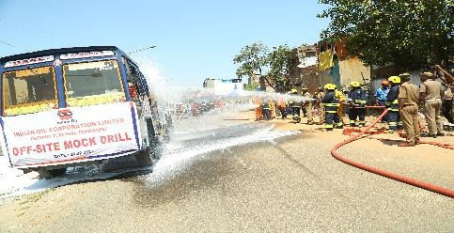
Contractor Commitment towards safety
Before award of any job, a commitment is taken from the contractor to comply all HSE parameters during execution of any work.
Inclusion of guidelines on safety in the tendering stage itself like General Conditions of Contract (G.C.C)/ Special Conditions of Contract (S.C.C) ensures safety standard during execution of the contract.
It is ensured that the contractor provides adequate means and establishes a suitable programme on safety & health for workers, consistent with National/State laws and regulations. OISD guideline OISD-GDN-192 on Safety Practices during Construction forms a part of the tender document.
Incident Investigation
All incidents are investigated with the objective of learning and to avoid repetitive shortcomings. Recommendations are implemented in time bound manner. All jobs in the plants are carried out through a systematic Work Permit System to ensure that safety precautions are taken in line with the norms of Oil Industry Safety Directorate (OISD).
Fire-fighting
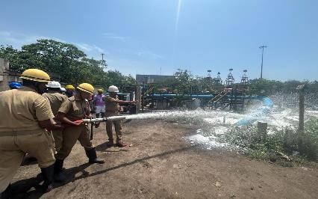
IndianOil has an elaborate fixed as well as mobile firefighting system backed by dedicated fire fighting crew to take care of emergencies/eventualities. A well-structured Emergency Management Plan at each location is in place to meet these requirements. System effectiveness is ensured through regular mock drills.
Fire fighting/ protection facilities are designed as per Oil Industry Safety Directorate (OISD) norms which are based on reputed international codes like American Petroleum Institute (API), USA, National Fire Protection Association (NFPA), USA, Institute of Petroleum (IP), UK etc as well the industry experience.
Water spray system/ sprinklers are provided in vulnerable areas like storage tanks, columns and hot pumps. Semi-fixed foam system has also been provided in storage tanks storing crude/petroleum products. Hydrocarbon detectors are provided in vulnerable areas of all installations including LPG locations for early leak detection.
Emergency Response Disaster Management Plans (ERDMP) as per PNGRB guidelines are in place for all installations. Agreements are in place with neighbouring industries and District Authorities for Mutual Aid. On-site and Off-site Disaster drills are conducted as per calendar.

13. Maintenance & HR

Maintenance
IndianOil’s Pipelines Division plays a crucial role in providing comprehensive operation and maintenance services for cross-country pipeline systems. These services cater to both existing pipeline networks and companies entering the pipeline business. The maintenance activities include the operation and upkeep of crude oil and multi-product pipelines, along with associated equipment such as mainline engines, pumps, motors, and station facilities including storage tanks. Advanced automation and control systems are also maintained to ensure efficient and reliable pipeline operations.
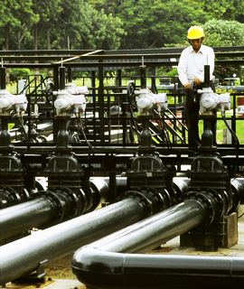
The division also focuses on the development of structured maintenance procedures, schedules, manuals, and formats to standardize operations. Special attention is given to corrosion monitoring and control to enhance the lifespan of pipelines and prevent failures. Additionally, technical audits are conducted regularly to improve performance in terms of energy efficiency, product quality, safety, and environmental protection. The selection, testing, and evaluation of chemical drag reducers and corrosion inhibitors further contribute to optimizing pipeline performance and reducing operational losses.
IndianOil also emphasizes safety and preparedness through the implementation of onsite and offsite disaster management plans. Maintenance activities are supported by a team of expert engineers located across the country, ensuring timely inspection, troubleshooting, and support. These integrated maintenance practices ensure safe, efficient, and uninterrupted pipeline operations.

Human Resources (HR)
The Human Resources (HR) Department at IndianOil plays a vital role in supporting plant operations by managing workforce-related functions and ensuring a structured and compliant work environment. HR operates in accordance with company policies and statutory regulations, covering areas such as recruitment, employee conduct, performance management, and welfare. It ensures compliance with important labour laws including Provident Fund (PF), Employee State Insurance (ESI), and the Contract Labour (Regulation and Abolition) Act.
HR is also responsible for maintaining a safe, inclusive, and employee-friendly workplace. It ensures strict adherence to safety and ethical standards, including the implementation of the Prevention of Sexual Harassment (POSH) Act and the formation of an Internal Complaints Committee (ICC). The department promotes employee well-being through welfare initiatives, medical facilities, and engagement activities, contributing to higher morale and productivity.
In addition, HR manages attendance, leave, payroll processing, and training programs for employees and trainees. It also plays a key role in industrial relations by addressing grievances, maintaining discipline, and ensuring smooth communication between management and workers. Through these efforts, HR contributes significantly to the efficient functioning and overall success of the organization.

14 LEARNING OUTCOME
The industrial training at the Lube Blending Plant (LBP), Chennai provided extensive exposure to the real-time application of Electronics and Computer Engineering concepts in an industrial environment. One of the major learning outcomes was understanding the role of automation systems such as SCADA (Supervisory Control and Data Acquisition) in monitoring and controlling complex industrial processes. We observed how SCADA systems collect real-time data from various field instruments and provide a centralized interface for operators to monitor parameters such as flow rate, temperature, pressure, and tank levels. This helped us relate theoretical concepts of data acquisition, human-machine interface (HMI), and industrial communication systems to practical implementation.
Another important learning outcome was gaining in-depth knowledge of industrial instrumentation and sensor technologies. We were exposed to devices such as radar level gauges, temperature sensors, mass flowmeters, and digital control valves, which are essential for accurate measurement and control in process industries. We understood how these sensors convert physical parameters into electrical signals, which are then transmitted to control systems for processing. The concept of signal conditioning, calibration, and accuracy in measurement systems became clearer through practical observation. Additionally, we learned about actuators such as motor operated valves (MOVs), which are controlled electronically to regulate the flow of materials, demonstrating the integration of hardware and control logic.
The training also enhanced our understanding of control systems and automation techniques used in industrial processes. We observed closed-loop control mechanisms where feedback from sensors is continuously used to adjust system parameters through controllers such as digital control valves. The role of batch controller units (BCU) in executing predefined operations and ensuring accurate quantity control was also studied. This gave us practical insight into control system concepts such as feedback, stability, and process optimization. Furthermore, we gained exposure to industrial communication protocols and how different subsystems are integrated to work as a unified automated system.
In addition, the training emphasized the importance of safety, reliability, and maintenance in automated industrial environments. We learned how safety interlocks, alarm systems, and emergency shutdown mechanisms are implemented using electronic and control systems to prevent accidents. The importance of preventive and predictive maintenance of instruments and control systems was also highlighted, ensuring accuracy and minimizing downtime. This helped us understand the practical challenges involved in maintaining system reliability and performance in real-world conditions.
Finally, the training provided valuable knowledge about the integration of computer engineering concepts such as data logging, database management, and system monitoring in industrial operations. SCADA systems store large volumes of operational data, which can be analyzed for performance improvement, fault detection, and decision-making. This exposure helped us understand how software and hardware systems work together in industrial automation. Overall, the training significantly enhanced our technical knowledge, practical skills, and understanding of how electronics and Computer Engineering plays a vital role in modern industrial processes and automation systems.

16. REFERENCES
The information presented in this report has been collected from various reliable sources, including industrial exposure, standard manuals, and technical references. The following sources were referred to during the preparation of this report:
- IndianOil Corporation Limited (IOCL) – Training materials and plant guidelines
- Lube Blending Plant (LBP), Chennai – Operational procedures and system overview
- ASTM Standards for Petroleum Testing and Analysis
- Oil Industry Safety Directorate (OISD) Guidelines and Safety Manuals
- Instrumentation and Process Control textbooks and lecture notes
- SCADA and Industrial Automation reference materials
- Maintenance and operation manuals of industrial equipment and instruments
These references provided valuable technical knowledge and helped in understanding real-time industrial processes and systems.

17. ACKNOWLEDGEMENT
I would like to express my sincere and heartfelt gratitude to IndianOil Corporation Limited (IOCL), Lube Blending Plant (LBP), Chennai, for providing me with the invaluable opportunity to undergo industrial training at such a prestigious organization. This training has been a highly enriching experience, allowing me to gain practical knowledge and exposure to real-time industrial operations, which greatly enhanced my understanding beyond classroom learning.
I am deeply thankful to the plant management and all the technical staff for their continuous guidance, support, and encouragement throughout the training period. Their willingness to share their knowledge, explain complex processes, and provide insights into plant operations, instrumentation, automation systems, and safety practices has been extremely beneficial. I am especially grateful to the engineers and supervisors who patiently guided us during plant visits and helped us understand the working of various systems such as SCADA, control valves, sensors, and blending operations.
I would also like to extend my sincere appreciation to the Human Resources (HR) Department for organizing and coordinating the training program efficiently. Their efforts in ensuring a well-structured schedule, providing necessary information, and maintaining a safe and professional learning environment played a crucial role in making this training successful. The awareness sessions on workplace safety, employee welfare, and organizational practices were particularly informative and added great value to our overall learning experience.
I am highly grateful to my faculty members and academic mentors for their constant encouragement, guidance, and support throughout the training and report preparation. Their valuable suggestions and feedback helped me in understanding the concepts more clearly and presenting them effectively in this report. Their motivation has been instrumental in successfully completing this work.
Finally, I would like to thank my fellow trainees and friends for their cooperation, teamwork, and support during the training period. The collective learning experience, discussions, and shared knowledge contributed significantly to enhancing my understanding. I also extend my gratitude to everyone who directly or indirectly contributed to the successful completion of this training and report.👍

